SMART HOME AUTOMATION – A DIGITAL TRANSFORMATION USING IOT

C. Anna Palagan1*& Dr. B. M.Praveen 2
1 PDF Scholar, Department of Electronics and Communication Engineering, Srinivas University, Mangalore, Karnataka – 574146, India,
Orcid-ID: 0000-0002-4549-0539; E-mail: annapalaganc7467@gmail.com
2 Director, Research and Innovation Council, Srinivas University, Mangalore, Karnataka – 574146, India,
*Corresponding Author annapalaganc7467@gmail.com

Abstract: In this context, "automation" refers to the practise of managing and running a wide range of mechanical and electronic devices, industrial processes, and computer-based software with little or no direct involvement from humans. The term "home automation" refers to the practise of automating the management of house electronics by means of a variety of control system methods. Several methods exist for manipulating electrical and electronic devices, such as fans, lights, and alarm echoes. In this research, we present an effective method of implementing IOT (Internet of Things), which can be used to keep tabs on and manage domestic appliances remotely through the Internet. As the primary interface, mobile devices are used in home automation systems. Through an Internet gateway, they may use low-power communication protocols like Wi-Fi to exchange data with the home automation network. The purpose of this work is to enable the management of domestic appliances from a mobile device, utilising a wireless local area network (Wi-Fi) and the BLYNK server system. The user interacts with the system in real time through a web interface, while common household items such as lights, fans, and door locks are managed from a central location. The capacity to detect smoke is an additional safety element that ensures employees get an alert message and a photograph of the fire scene on their smartphones immediately in the case of a fire. talks to the appropriate relays. The chosen stage is completely customizable and user-friendly, and experimental findings demonstrate that the IoT model provides a highly promising foundation for improving automated home performances.

KEYWORDS: Home Automation, Internet of Things, Automation of Home, BLYNK App, Wi Fi.

Introduction
The term "things" refers to the physical items that are connected and exchange data with other devices and systems through the internet through the use of embedded sensors, software, and other technologies known together as the "Internet of Things." These gadgets vary from the commonplace to the highly specialised. There are already more than 7 billion IoT devices online, but this figure is predicted to rise to 10 billion by 2020 and 22 billion by 2025. IoT has rapidly risen in prominence over the last several years to become one of the most consequential innovations of our time. Because of embedded devices, commonplace items like refrigerators, autos, thermostats, and baby monitors may now communicate with one another and with us through the internet.

In today's world, data may be easily shared and collected from physical objects with the use of low-cost computers, the cloud, big data, analytics, and mobile technologies. Every contact between interconnected items in today's hyperconnected environment may be recorded, monitored, and adjusted by digital systems. The analogue and the digital coexist and work together. Smarter living and working, as well as more independence, are all possible thanks to the IoT. IoT is not just useful for home automation thanks to the smart gadgets it provides, but also for commercial enterprises. The Internet of Things (IoT) gives organisations a window into their systems in real time, revealing information about anything from machine performance to supply chain and logistics operations.

Emerging technology known as the "web of things" (IoT) allows us to remotely manage various pieces of hardware and software anywhere in the world. Here, an alternative approach suggests web-based control of household appliances through the Internet of Things (IoT). This setup makes use of three shackles to represent the household light, fan, and electrical outlet. Our user-friendly interface makes it possible for anybody to take command of their home's electronic devices from anywhere in the world through the internet. An AVR microcontroller family device should be used for this architecture (Zafari, Papapanagiotou and Christidis, 2016). For online client direction retrieval, this microcontroller is connected to a wireless modem. The suggested solution also includes an LCD display for monitoring the system's health. Loads are shifted with the use of transfers. A 12 V transformer manages the whole structure. After receiving instructions from a client via the internet, the microcontroller uses those parameters to operate the loads as required and display the system's status on an LCD screen.

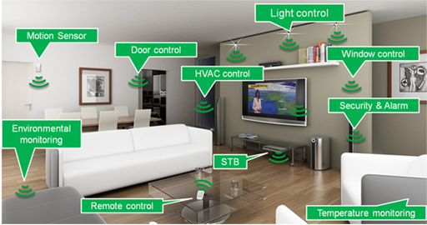

Figure 1: Home Automation and their overview

As the Internet of Things (IoT) has become more commonplace, its use has moved to more mundane, at-home tasks. IoT projects at home are driven by the need to monitor and save energy while also achieving and maintaining a high level of comfort. As shown in Figure 1, there are three main components of IoT-based home automation systems. The first part, "Art," entails the actual act of "detecting" and "acquiring" knowledge. To do this, sensors or devices (sometimes called objects) are placed at various points around the house to measure and collect data, such as temperature, humidity, or lighting levels.

The second part of the framework deals with the process of gathering and organising data. Data from sensors comes in a very basic format. This data is sent to the CPU through a wired or wireless connection. At this step, the processor translates the data into understandable characteristics. Both the user interface and the device to be managed in the future get these characteristics. The web is the last component of automation for the IoT. Most systems use a server to transmit data after processing, making it accessible to users. The internet may also be used to remotely monitor data and operate physical devices. Time is saved, homeowner satisfaction is increased, and energy is conserved thanks to robotization systems that automatically carry out a number of directives (Al-Kuwari et al., 2018).
Some countries throughout the world are beginning to feel a pressing need and growing interest in developing energy efficiency and sustainable power source innovations. Undergraduate competitions at colleges, which aim to raise students' awareness, have been linked to this mechanised development. One such competition that has been happening in the United States and other countries across the world is the sunlight-based Decathlon. The Solar Decathlon Middle East (SDME) is a newly formed competition scheduled to take place in Dubai in 2018. Participation in the SDME 2018 competition has allowed Qatar University to assemble a cross-disciplinary group of students to work on building a sustainable, intelligent, practical, and economically sound solar-powered home. A home that is both energy efficient and fully monitored and automated thanks to developments in the Internet of Things (IoT) (Patnaikuni, 2012).

2. Literature Review

Smartphone, Arduino board, and Bluetooth technology-based home automation solutions are safe and inexpensive. Riyale and M. Tazil presented a Bluetooth-based home automation system. A computer or mobile phone serves as the receiver in the Bluetooth system [1]. It may be used as a real-time system because of its high communication rate, high security, and cheap cost. The maximum range of a Bluetooth network is 10 metres. One of the primary drawbacks of Bluetooth based home automation systems [2] is that the smartphone will not be able to operate the house appliances if it is out of range.

A researcher has developed a voice-recognition-based system for automating household tasks [4]. Bluetooth is used for the wireless connection between the phone and the Arduino UNO [3]. Disabled and elderly persons who wish to use voice commands to operate household equipment may benefit greatly from this. The fundamental problem with this system is that it relies on a high signal-to-noise ratio (SNR) for effective communication between the user and the speech recognition tool. If the SNR is low, the accuracy of the system will suffer.

ZigBee, which is related to Bluetooth technology, has also been investigated as the basis for a wireless home automation system [7]. As a widely used transceiver standard, its low data rate and power consumption are advantages. Its effective range is about 10–20 metres, however with DSSS [6] it may extend to as far as 150 metres. It works well for prototyping and other research-related endeavours. The integration of Global System for Mobile Communication into a home automation system (GSM). Messages are sent back and forth between the central module and the many household appliances in GSM-based home automation systems [8]. The fundamental problem with GSM-based home automation systems is that they are not always dependable because of the lack of assurance that text messages will be sent to the system. These problems are inherent in conventional approaches; we're using "IOT-Based Smart security and Smart Home Automation [9]" to address them.

Improved efficiency, accuracy, and economic gain may be achieved via the use of IoT since it enables remote sensing and control of things using preexisting network infrastructure. These days, most people have access to super-fast 5G LTE cellular internet, which has paved the way for the development of lightning-fast IoT-based home automation systems [10].

Adding sensors and actuators to IoT makes it an example of the broader class of cyber-physical systems, which includes technologies like the control of various household appliances, such as lights, fans, water pumps, and so on. To integrate sensor data into users' regular activities, a system was developed [11]. There are already a plethora of smartphone-centric remote controller options on the market. However, existing solutions constantly suffer from platform compatibility issues, and the GUI in such systems is notoriously difficult to use.

This study suggests a method to improve and streamline the monitoring and control process. Using information gathered from sensors placed around the house, appliances may be remotely operated according to predetermined parameters [12]. A microcontroller collects the data from the sensors and sends it to a WEB server, where it may be accessed by a mobile app. Experiments and implementations have shown the potential of the proposed system and platform to expand the range of useful IoT applications in everyday life. Modeling a system that integrates sensors and actuators [13] is possible now that people increasingly rely on mobile phone apps to cope with everyday situations. Microcontroller PIC16F887 for controlling household appliances through cellular network. [14]. It offers superior availability, coverage, and security at the expense of an expensive SMS. Through the GSM network, AT instructions may be transmitted to operate the house's electronics. No Hardware, Equipment, or Machinery is present in the System. System with a Single Overarching Controller Status Indicators Via Sensor Interface for Ethernet, Bluetooth, GSM, and Wi-Fi National Seminar on Emerging Trends in Data Mining: An International Journal of Computer Applications (0975-8887) Special Issue (RTDM 2016) The user is responsible for remembering the 8 states associated with their devices.

Using GSM technology, the appliances are controlled by an Arduino board. To accomplish this interface, it employs certain peripheral drivers and relays. The smartphone software receives the user's instructions and then sends SMS messages to the GSM modem connected to the Arduino, which in turn controls the household appliances [15]. Cost and SMS dependability are two areas where the method falls short. Unfortunately, an interface cannot be modified per-device. For the purpose of home automation, the Arduino board and Bluetooth board have been invented and developed[16]. The Python programming language is used to create a user interface for the mobile device. The devices to be controlled and monitored are interfaced with through I/O ports on the Bluetooth board and relays. To prevent unauthorised access, a password protects the Bluetooth feature. A Bluetooth connection may reach from 10 to 100 feet.

3. Proposed System

As the digital world continues to develop and people's perspectives on the importance of technology in their personal and professional lives shift, so will the kinds of innovations that make the Internet of Things possible. There are two primary sections to this study. Both the hardware and the software are essential. Bulb, relay, microcontroller (node), exhaust fan LED, and relay are the major components of the hardware. The only software required is the BLYNK app and server for Android. A web page BLYNK app) with a user-customizable front end may be used to regulate and monitor the load. Users with authorised IP addresses may provide instructions to the circuit's node MCU microcontroller through the Wi-Fi module.

The Wi-Fi adapter may connect to the web using any available wireless modem. A software inside a Wi-Fi module carries out the instructions it receives. To manage your house from your smartphone, you'll need to set up a local network for the ESP32 and link the Wi-Fi module ESP8266 to it. This BLYNKapp delivers ON/OFF instructions to ESP32 over the BLYNK server when the user touches the corresponding widgets in the BLYNK app. When an input is received, the ESP32 will flip the appropriate relays. Therefore, loads linked to relays may be turned on and off. The same holds true for the appliances in our homes; we may use manual switches to operate them. The AC loads may be controlled by connecting the relays' outputs to the switches. When the manual ON or OFF relay is activated, the associated AC loads are turned on and off automatically.

3.1. Smart Home Automation Architecture:

To manage your house from your smartphone, you'll need to set up a local network for the ESP32 and link the Wi-Fi module ESP8266 to it. This BLYNKapp delivers ON/OFF instructions to ESP32 over the BLYNK server when the user touches the corresponding widgets in the BLYNK app. When an input is received, the ESP32 will flip the appropriate relays. Therefore, loads linked to relays may be turned on and off. The same holds true for the appliances in our homes; we may use manual switches to operate them. The AC loads may be controlled by connecting the relays' outputs to the switches. When the manual ON or OFF relay is activated, the associated AC loads are turned on and off automatically.

The previously mentioned examined factors in houses are selected to provide alert, efficient, and welcoming environments. Therefore, a single hub is built to monitor factors such as heat, humidity, light intensity, proximity, and carbon monoxide. Each room of the home may have one of these centres installed, preferably in an off-center position above the floor and below the ceiling. The data collected may be processed and utilised to manage smart devices like LED lights and climate control systems. Figure 2 depicts a schematic of the planned plan's infrastructure. It consists of the sensors, CPU, user interface, and information communication and transmission links. Temperature and stickiness sensors were the first consideration in the design process. The LM35 temperature sensor and the HIH4000 stickiness sensor were selected. Reasons for these choices included smaller diameters in comparison to other sensors like DHT22, as well as reduced prices.

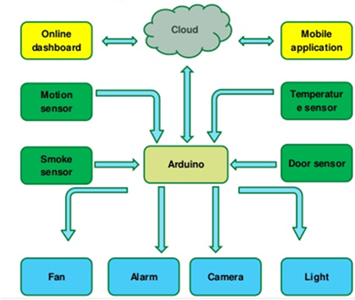

Figure 2: Smart Home Automation Architecture

The term "home automation" refers to a system that uses the internet to connect and coordinate many electrical appliances and gadgets in a single household. Whether you're at home or thousands of miles away, you can control your smart home devices with the tap of an app on your smartphone or tablet thanks to Wi-Fi and built-in sensors. You may use the remote to activate the lights, lock the front door, check the weather, detect fires, and operate the windows.

Home automation works on three levels:

- When devices are monitored, users may do remote checks using a dedicated app. A smart security camera's live stream, for instance, might be seen by an unauthorised party.
- When a user has authority over their gadgets, they may do things like remotely pan a security camera to get a better look at their living quarters.
- Finally, automation refers to the process of programming devices to interact with one another in predetermined ways, such as when a motion-activated security camera sets off a smart alarm. Light, temperature, and motion are just some of the things that sensors can track. With the help of a home automation system, you may personalise all of these features and more.

A controller is any electronic device (PC, tablet, or smartphone) used to transmit and receive data regarding the operation of a home automation system. The mechanical parts of a home automation system are called actuators, and they might be things like light switches, motors, or motorised values. They can be triggered by sending a signal from a controller, since that is how they were designed to work. These include the MQ2 sensor, Ultrasonic sensor, DHT22 sensor, LM393 LDR Sensor, TSOP sensor, and MC38 sensor, all of which are used in this project's smart home automation, monitoring, and alerting system to detect a variety of applications. The smoke is detected using a MQ2 sensor. A temperature sensor known as a DHT22. This allows us to adjust the fan speed according to the room's temperature. Automatic lighting control LM393 LDR sensor. The MC38 sensor is a control device for doors and windows.

3.1.1. Arduino Microcontroller

An Atmega2560 microprocessor runs the show here. The microcontroller's 256 KB of memory is split between the bootloader's Flash programme memory (which uses 8 KB) and static random access memory (which uses the remaining 224 KB) (SRAM). A soil moisture sensor, a float sensor, an LCD display interface, and an RFID module interface make up the four main parts of the hardware. The ATmega2560 microprocessor manages all of these features, and the Arduino IDE provides the essential software for doing so (IDE). There are 54 digital I/O pins (14 of which may be used as PWM outputs), 16 analogue I/O pins, 4 hardware serial ports (UARTs), a 16 MHz crystal oscillator, a USB port, a power connector, an ICSP header, and a reset button. Everything you need to run the microcontroller is included; all you have to do is plug it into a computer's USB port or provide power through an AC-to-DC converter or battery. Shields designed for the Duemilanove and Diecimila may also be used with the Mega.

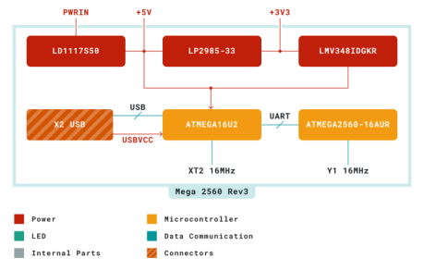

Figure 3: Block Diagram of Arduino MEGA2560

3.1.2. Use case 1: user access to the system.

An Atmega2560 microprocessor runs the show here. The microcontroller's 256 KB of memory is split between the bootloader's Flash programme memory (which uses 8 KB) and static random access memory (which uses the remaining 224 KB) (SRAM). A soil moisture sensor, a float sensor, an LCD display interface, and an RFID module interface make up the four main parts of the hardware. The ATmega2560 microprocessor manages all of these features, and the Arduino IDE provides the essential software for doing so (IDE). There are 54 digital I/O pins (14 of which may be used as PWM outputs), 16 analogue I/O pins, 4 hardware serial ports (UARTs), a 16 MHz crystal oscillator, a USB port, a power connector, an ICSP header, and a reset button. Everything you need to run the microcontroller is included; all you have to do is plug it into a computer's USB port or provide power through an AC-to-DC converter or battery. Shields designed for the Duemilanove and Diecimila may also be used with the Mega.
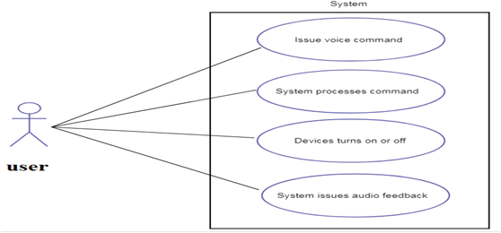

Figure 4: User access to the system

The term "home automation" refers to a system that uses the internet to connect and coordinate many electrical appliances and gadgets in a single household. Whether you're at home or thousands of miles away, you can control your smart home devices with the tap of an app on your smartphone or tablet thanks to Wi-Fi and built-in sensors. You may use the remote to activate the lights, lock the front door, check the weather, detect fires, and operate the windows. Automation in the home functions on three levels: Remote device checking in through app is what we mean when we talk about monitoring. A smart security camera's live stream, for instance, might be seen by an unauthorised party. The term "control" is used to refer to the user's ability to remotely manipulate these gadgets. Last but not least, automation is establishing a network of interconnected devices that can be activated by one another; for example, a smart siren may sound anytime a motion-activated security camera detects activity.

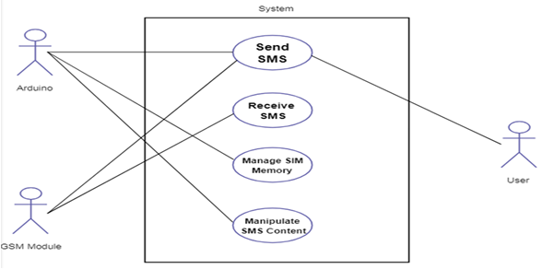

Figure 5: System control

Light, temperature, and motion are just some of the things that sensors can track. With the help of a home automation system, you may personalise all of these features and more. A controller is any electronic device (PC, tablet, or smartphone) used to transmit and receive data regarding the operation of a home automation system. The mechanical parts of a home automation system are called actuators, and they might be things like light switches, motors, or motorised values. They can be triggered by sending a signal from a controller, since that is how they were designed to work. The goal of this project is to create a smart home automation, monitoring, and alerting system that uses a variety of sensors to detect various applications. A few examples of these sensors include the MQ2 sensor, the Ultrasonic sensor, the DHT22 sensor, the LM393 LDR sensor, the TSOP sensor, and the MC38 sensor. The MQ2 smoke detector sensor. A temperature sensor known as a DHT22. This allows us to adjust the fan speed according to the room's temperature. Automatic lighting control LM393 LDR sensor. The MC38 sensor is a control device for doors and windows. The clock speed ranges from 80 MHz to 240 MHz, and the two CPU cores may be regulated independently. In addition to keeping an eye on the peripherals for changes or threshold crossings, the user may turn off the CPU and utilise the low-power co-processor instead.
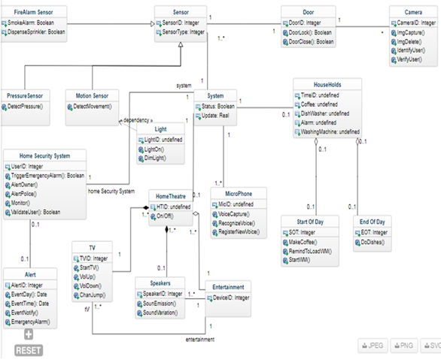

Figure 6: Class Diagram

3.2 WORKING PRINCIPLE

For any Internet of Things (IoT)-based initiative to succeed, cutting-edge technology is essential. This is because the digital world is always changing, and with it, our expectations for how we should use it in our personal and professional lives. There are essentially two halves to this endeavour. Both the hardware and the software are essential. Bulb, relay, microcontroller (node), exhaust fan LED, and relay are the major components of the hardware. An Android BLYNKapp and server make up the whole of the software component. A web page BLYNK app) with a user-customizable front end may be used to regulate and monitor the load. The Wi-Fi module of the node MCU micro controller receives orders from the user through the permitted IP address.

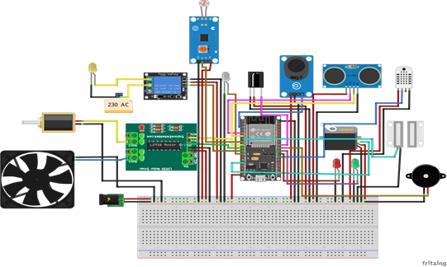

Figure 7: Schematic Diagram

The Wi-Fi adapter may connect to the web using any available wireless modem. A software inside a Wi-Fi module carries out the instructions it receives. To manage your house from your smartphone, you'll need to hook up both your mobile device and the Wi-Fi module ESP8266 found on the ESP32 to a network. This BLYNK app sends ON/OFF instructions to ESP32 through the BLYNK server when the user touches the designated position of widgets inside the app. When an input is received, the ESP32 will flip the appropriate relays. Therefore, loads linked to relays may be turned on and off. The same holds true for the appliances in our homes; we may use manual switches to operate them. The AC loads may be controlled by connecting the relays' outputs to the switches. When a manual ON or OFF relay is activated, the associated AC loads will turn on and off at the appropriate times.
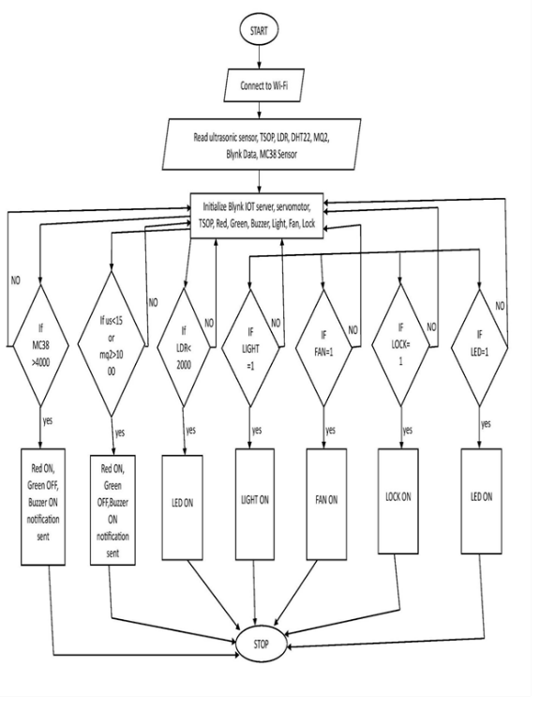
Figure 8: Flow Chart

4. Experimental analysis

In order to gather data and aid the analyst in understanding the system's requirements, meetings are used. In these meetings, different groups of home users get together to discuss topics like "what kind of home computerization features are required?" After these meetings, the questioner asks the reliable people to present a series of questions and compiles the results in a report.

Simply use your phone or one of the accompanying smart labels to lock and unlock your door. You may manage many properties simultaneously and restrict access to the keys from anywhere on the earth. This smart door lock doesn't have to use Bluetooth like many others on the market.

The smart lock may be easily integrated into your home's existing locking system, turning your iPhone into a key. It is also compatible with the whole line of Weiser Smart Key locks and keys. The mobile app allows you to handle your keys and lock from any location.

Thanks to Z-wave technology, the sensor is compatible with a wide variety of smart home systems administration hub points, and it can be used to remotely monitor anything that opens and shuts.

The use of remote sensors allows for an efficient, always-on monitoring system. The almost infinite scalability means you can rest easy knowing your whole house, no matter how big or little, is protected.

Having sensors installed on your doors and windows will give you peace of mind since you will always be aware of who is entering and exiting your property. When the sensor is compromised, this Z-wave powered device will sound an alert.

The cost of installing a standard security system in your house is far more than it would be to install your own customized system, but thanks to technological advancements, you can now do it for a fraction of that cost. This model has all the necessary components to quickly reach full functionality.

The previously mentioned examined factors in houses are selected to provide alert, efficient, and welcoming environments. Therefore, a single hub is built to monitor factors such as heat, humidity, light intensity, proximity, and carbon monoxide. Each room of the home may have one of these centres installed, preferably in an off-center position above the floor and below the ceiling. The data collected may be processed and utilised to manage smart devices like LED lights and climate control systems.

As shown in Figure 12, the suggested plan's configuration is depicted in schematic form. It consists of the sensors, CPU, user interface, and information communication and transmission links. Temperature and stickiness sensors were the first consideration in the design process. The LM35 temperature sensor and the HIH4000 stickiness sensor were selected. Reasons for these choices included smaller diameters in comparison to other sensors like DHT22, as well as reduced prices.

Conclusion and Future Scope:

Using various sensors and household equipment, this work may be improved further. The widespread use of smartphones means that this intuitive approach may be put to widespread use. In addition, the system's price is manageable. The same circuit that is used to regulate the speed of an AC fan may be used to control the brightness of an AC light. Automatic shutoff and message sending are both helpful safety features that may be included into air conditioners and geysers. The geyser may be programmed to switch off when the water reaches a certain temperature, and the air conditioner can be set to turn off when the room temperature reaches a certain threshold. Via each of these scenarios, the user may get alerts in his or her Blynk app. Companies that specialize in building mobile apps have whole departments devoted to creating cloud-based applications that make use of the Internet of Things. Anyone using a smart phone can easily keep an eye on and adjust the home's electronics, not only the elderly or those with mobility issues. The rate of adoption for mobility solutions based on the Internet of Things (IoT) that automate company operations and end-to-end processes is expected to rise as knowledge of their benefits increases.
The Internet of Things (IoT) may be used in almost every industry. The information era influences almost every aspect of our hectic daily lives. In this information era, it's safe to argue that technological advancements are as much a part of daily life as breathing for the human species. The industrial sector is a natural fit for our cutting-edge technologies. Advanced detection in hazardous environments, including mines, laboratories, and automobiles.

References
- B. Ramana Naik and C. Shashikanth “Strength Atzori, L., Iera, A., and Morabito G.; “The internet of things: A survey.”; Computer networks, 2010 55(15), 2787-2805.
- Mandula, K., Parupalli, R., Murty, C. A., Magesh, E., and Lunagariya, R.; “Mobile based home automation using Internet of Things (IoT).” International IEEE Conference on Control, Instrumentation, Communication and Computational Technologies (ICCICCT), December 2015, pp. 350-353.
- Bohora, B., Maharjan, S., and Shrestha, B. R; “IoT Based Smart Home Using Blynk Framework”. Zerona Scholar, (2016). 1(1), 26-30.
- Wang, M., Zhang, G., Zhang, C., Zhang, J. and Li, C.; “An IoT-based appliance control system for smart homes.” Fourth IEEE International Conference on Intellelligent Control and Information Processing (ICICIP), June 2013.
- A.R. C. Y. O. K. Withanage, c.,” A comparison of the popular home automation technologies” pp. 1-11, may 2014.
- B. S. S. Tharaniya soundhari, M., “Intelligent interface-based speech recognition for home automation using android application. 1-11, march 2015.
- B. R. Pavithra, D., “IoT based monitoring and control system for home automation”, pp. 169– 173, April 2015.
- F. M. G. K. D. Sukmana, Husni Teja, “Wireless and mobile (apwimob), 2015 ieee asia pacific conference on”, pp. 183 – 187, august 2015.
- E. A. Elkamchouchi, H., “Design and prototype implementation of SMS based home automation system”, pp. 162 – 167, November 2012.
- T. Ming Zhao, Chua, “Automatic face and gesture recognition, 2008. fig ’08. 8th ieee international conference on”, pp. 1–6, September 2008.
- Mane, M. A., Pol, M. P., Patil, M. A., and Patil, M; “IOT based Advanced Home Automation using Node MCU controller and Blynk App.”; 13th Intl. Conf. on Recent
- Innovations in Science, Engineering and Management, Feb. 2018.
- L.-W. Chen, J.-H. Cheng, and Y.-C. Tseng, Optimal path planning with spatial-temporal mobility modeling for individual-based emergency guiding, IEEE Trans. Syst., Man, Cybern., Syst., vol. 45, no. 12, pp. 14911501, Dec. 2015
- L.-W. Chen and J.-J. Chung, Mobility-aware and congestion-relieved dedicated path planning for group-based emergency guiding based on Internet of Things technologies, IEEE Trans. Intell. Transp. Syst., vol. 18, no. 9, pp. 24532466, Sep. 2017.
- N. Najem, D. B. Haddou, M. R. Abid, H. Darhmaoui, N. Krami, and O. Zytoune, Context-aware wireless sensors for IoT-centric energy efficient campuses, in Proc. IEEE Int. Conf. Smart Comput. (SMART- COMP), May 2017, pp. 16.
- M. V. Moreno et al., Applicability of big data techniques to smart cities deployments, IEEE Trans. Ind. Informat., vol. 13, no. 2, pp. 800809, Apr. 2017.

